SHIVAGADHI ENGLISH SCHOOL
First Internal Evaluation - 2082
Sub: Maths Class: 3
Time: 2 hrs Theme: 1 & 2
Name: ___________________________________________________ Roll.No. _________
1. Write the time in hour, minute and second watching the clock.
a) b)
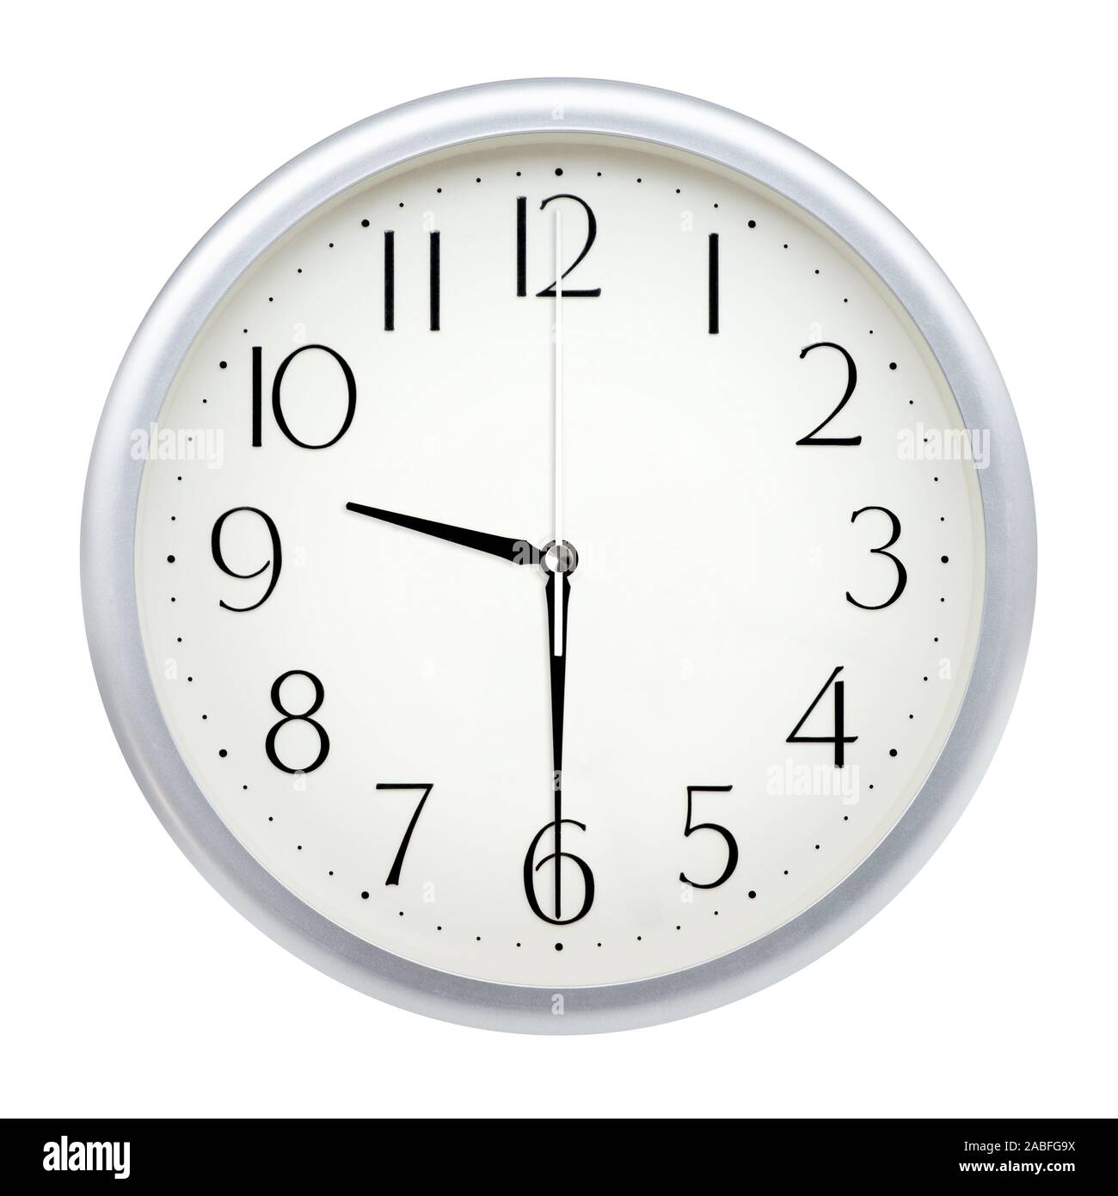
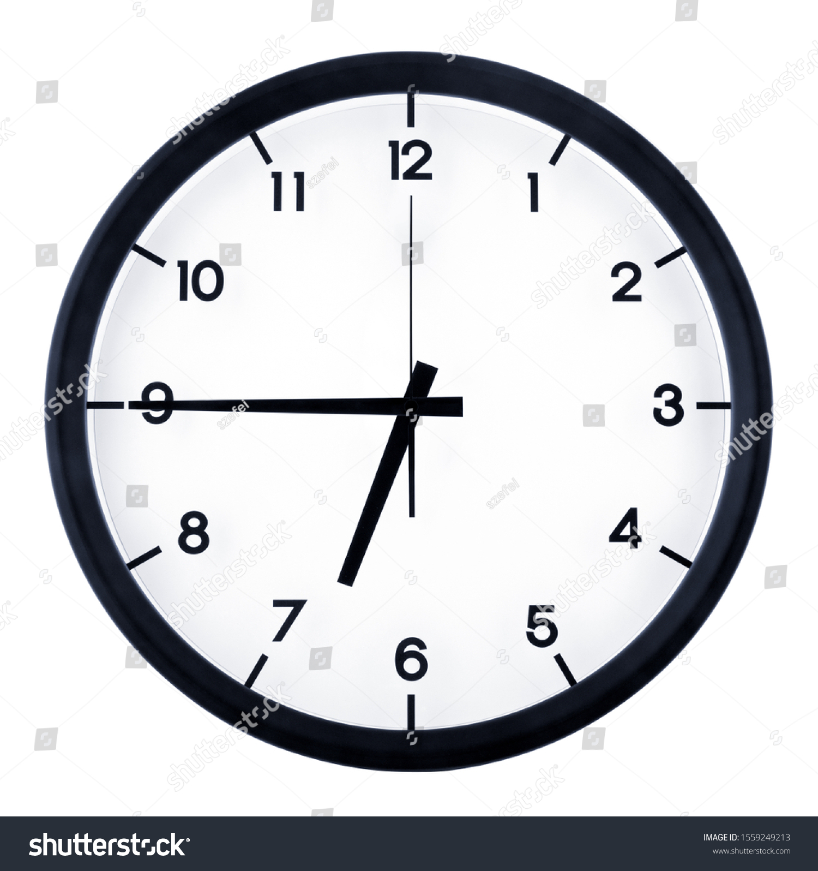

______________ _____________
2. Write the relation between year and month, month and week, week and day, day and
hour, hour and minuters and minutes and second.
- 1 year = ______________ months.
- 1 month = ______________ days.
- 1 week = _______________ days.
- 1 day = ______________hours.
- 1 hour = _____________ minutes.
- 1 minute = ___________ seconds.
3. Write the numbers according to ascending order by comparing given number upto 4
digits.
- 2129, 5487, 6805, 3214
_______ _______ _______ _______
- 7148, 9246, 1000, 2000
_______ _______ _______ _______
4. Write the numbers according to descending order by comparing given number upto 4
digits.
- 9241, 2312, 3133, 4212
_______ _______ _______ _______
- 3000, 5000, 5231, 9999
_______ _______ _______ _______
5. Write local numbers system up to 20 (Devnagari numerals). १-२०
6. Match correct fractions:
i) Two - thirds $\frac{3}{4}$
ii) Three - fourths $\frac{1}{4}$
iii) One - third $\frac{1}{2}$
iv) One - second $\frac{1}{3}$
v) One - fourth $\frac{2}{3}$
7. Write place value of the underline numbers up to 5 digits in Devanagari numeric system.
i) 45830 ii) 25371 iii) 78291 iv) 14652
___________ __________ ___________ __________
8. Write the place value of the circle numbers up to 5 digits in Hindu arabic numeric
system.
i) 21000 ii) 32401 iii) 41231 iv) 99999
___________ __________ ___________ __________
9. Write the appropriate sign '=' , '<' , '>' between these numbers to compare them.
a) 5 _________8 b) 8 _______5
c) 21 ________ 21 d) 345 ______435
THE END

